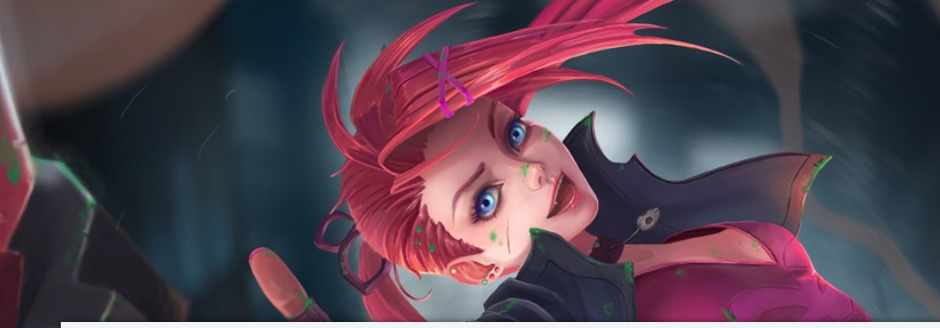
Hgihvhjgftdtfyugyeuiygurhbnfkbkf
Fhfjhgirhgh
Nfoireyiqbzknxc

